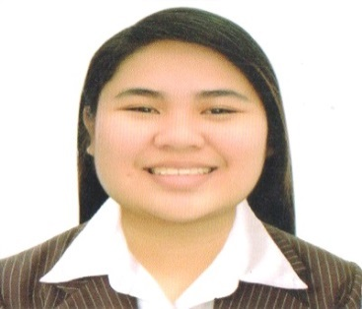**ABIAN, MICAH ELLA V.**

images.jpg4 5061 Malvar St. South Cembo, Makati City

images (1).jpg(+ 0916-335-6839/0966-463-6943

download (1).jpg [micahabian133@gmail.com](mailto:micahabian133@gmail.com)

**OBJECTIVE**

*“To acquire the understanding of how to offer best performance and to gain knowledge of daily operations of the company”*

**EDUCATIONAL BACKGROUND**

2013 – 2016 **COLEGIO DE SAN JUAN DE LETRAN**

Intramuros, Manila

Bachelor of Science in Business Administration

Major in Financial Management

2012 – 2013 **COLEGIO DE SAN JUAN DE LETRAN**

Intramuros, Manila

Bachelor of Science Major in Accountancy

2008 – 2012 **PITOGO HIGH SCHOOL**

Negros St., Brgy.Pitogo, Makati City

High School Diploma

**WORK EXPERIENCE**

**ACCENTURE, Inc. (Uptown Tower 1)**

Nov 2016 - Present

* Transaction Processing New Associate
* Responsible for research and reviews of business websites that offer services to households in US. Check legitimacy of the service by gathering data on licenses and suspicious pricing.
* Work closely with Service Delivery Leads internally and with client stakeholders to align on - Reviewing list of Google Home Services leads to determine if leads provide the right level of service, have the right licenses, and perform other checks
* For leads that meet initial qualifications and checks, build a defined profile for the lead capturing offered services and additional required information for outbound sales team
* Provide ratified list of leads and profiles back to Google Home Services team for action and tracking

**ON-THE-JOB TRAINING**

**ROYAL CANIN PHILIPPINES, INC. (A division of Mars, Inc.)**

11th Floor Net One Center

Bonifacio Global City, Taguig

Service and Finance Department

Nov. 27, 2015 – February 12, 2016

* Peach Tree Premium Accounting Distribution of 2010
* Purchase Journal Voucher/ Expense Report/ BIR Form no. 2307
* Manual check/Paylink check (Preparation and Releasing of check payments)

**SKILLS**

* Computer Literate (Microsoft Office – MS Excel, MS Outlook, MS Word, and MS Powerpoint; Google Docs – Google Sheet, Google Slide, Google Doc)

**CERTIFICATION**

* Certificate of Eligibility - Professional

**ACTIVITIES/SEMINARS ATTENDED**

Aug. 30, 2016 **Introduction to Stakeholder Management**

Cybergate Tower 2

Seminar offered by Accenture, Inc.

March 2016 **Business Analytics**

Cybergate Tower 2

Seminar offered by Accenture, Inc.

Feb. 29, 2016 **El Camino Al Exito (The Road to Success)**

The Manila Ballroom, Marriott Hotel Manila

Physical Committee Member

**REFERENCES**

Supervisor **Ms. Cathrina Del Carmen**

09178654825

Royal Canin Philippines, Inc.

Team Lead - Supervisor **Mr. Rene Sotto**

Accenture, Inc.

Quality Assurance Analyst **Ms. Shiela Aguado**

09178654825

Accenture, Inc.